# CREACION DE TABLAS

CREATE TABLE Caracteristicas (id_caracteristicas NUMBER(3) PRIMARY KEY NOT NULL,

peso VARCHAR2(5) NOT NULL,

altura VARCHAR2(5) NOT NULL,

color VARCHAR2(10) NOT NULL,

sexo VARCHAR2(10) NOT NULL);

CREATE TABLE Generacion (id_generacion NUMBER(1) PRIMARY KEY NOT NULL)

CREATE TABLE Region (id_region NUMBER(1) PRIMARY KEY NOT NULL,

nombre_region VARCHAR2(20) NOT NULL,

extension VARCHAR2(20) NOT NULL,

id_generacion NUMBER(1) NOT NULL,

CONSTRAINT id_generacion_fk FOREIGN KEY (id_generacion) REFERENCES Generacion(id_generacion));

CREATE TABLE Entrenador (id_entrenador NUMBER(5) PRIMARY KEY NOT NULL,

nombre VARCHAR2(20) NOT NULL,

pokemon VARCHAR2(2) NOT NULL,

num_pokemons NUMBER(1) NOT NULL,

id_region NUMBER(1) NOT NULL,

CONSTRAINT id_region_fk FOREIGN KEY (id_region) REFERENCES Region(id_region));

CREATE TABLE Pokemon (num_pokedex NUMBER(3) PRIMARY KEY NOT NULL,

tipo VARCHAR2(15) NOT NULL,

naturaleza VARCHAR2(15) NOT NULL,

id_generacion NUMBER(1) NOT NULL,

id_entrenador NUMBER(5) NOT NULL,

CONSTRAINT id_generacionPokemon_fk FOREIGN KEY (id_generacion) REFERENCES Generacion(id_generacion),

CONSTRAINT id_entrenadorPokemon_fk FOREIGN KEY (id_entrenador) REFERENCES Entrenador(id_entrenador));

CREATE TABLE Tiene (num_pokedex NUMBER(3) NOT NULL,

num_evoluciones NUMBER(1) NOT NULL,

CONSTRAINT num_pokedex_fk FOREIGN KEY (num_pokedex) REFERENCES Pokemon(num_pokedex));

CREATE TABLE Cuenta (num_pokedex NUMBER(3) NOT NULL,

id_caracteristicas NUMBER(3) NOT NULL,

CONSTRAINT num_pokedexCuenta_fk FOREIGN KEY (num_pokedex) REFERENCES Pokemon(num_pokedex),

CONSTRAINT id_caracteristicas_fk FOREIGN KEY (id_caracteristicas) REFERENCES Caracteristicas(id_caracteristicas));

# INSERTAR DATOS

## Tabla Características

Nota: Modificamos la columna peso, ya que no era posible introducir todos los pesos deseados

ALTER TABLE caracteristicas MODIFY peso VARCHAR(20)

INSERT INTO Caracteristicas VALUES(001, '6.9Kg', '0.7m', 'Verde', 'F')

INSERT INTO Caracteristicas VALUES(004, '8.5Kg', '0.6m', 'Rojo', 'F')

INSERT INTO Caracteristicas VALUES(007, '9Kg', '0.5m', 'Azul', 'M')

INSERT INTO Caracteristicas VALUES(387, '10.2Kg', '0.4m', 'Verde', 'F')

INSERT INTO Caracteristicas VALUES(390, '6.2Kg', '0.5m', 'Marrón', 'M')

INSERT INTO Caracteristicas VALUES(393, '5.2Kg', '0.4m', 'Aul', 'F')

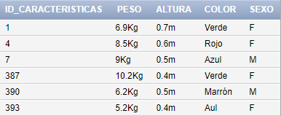

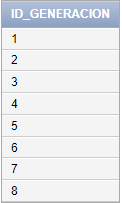

## Tabla generación

INSERT INTO generacion VALUES(1)

INSERT INTO generacion VALUES(2)

INSERT INTO generacion VALUES(3)

INSERT INTO generacion VALUES(4)

INSERT INTO generacion VALUES(5)

INSERT INTO generacion VALUES(6)

INSERT INTO generacion VALUES(7)

INSERT INTO generacion VALUES(8)

## Tabla región

INSERT INTO region VALUES(1, 'Kanto', '28 rutas', 1)

INSERT INTO region VALUES(2, 'Johto', '20 rutas', 2)

INSERT INTO region VALUES(3, 'Hoenn', '33 rutas', 3)

INSERT INTO region VALUES(4, 'Sinnoh', '30 rutas', 4)

INSERT INTO region VALUES(5, 'Teselia', '23 rutas', 5)

INSERT INTO region VALUES(6, 'Kalos', '22 rutas', 6)

INSERT INTO region VALUES(7, 'Alola', '17 rutas', 7)

INSERT INTO region VALUES(8, 'Galar', '10 rutas', 8)

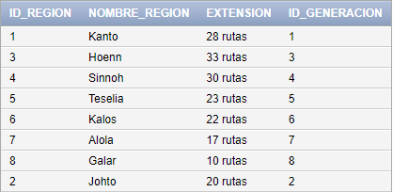

## Tabla Entrenador

INSERT INTO entrenador VALUES(1, 'Ash Ketchum', 'Si', 6, 1)

INSERT INTO entrenador VALUES(2, 'Morti', 'Si', 4, 2)

INSERT INTO entrenador VALUES(3, 'Lectro', 'Si', 5, 4)

INSERT INTO entrenador VALUES(4, 'Lario', 'Si', 5, 7)

INSERT INTO entrenador VALUES(5, 'Catleya', 'Si', 3, 5)

INSERT INTO entrenador VALUES(6, 'Lance', 'Si', 5, 1)

INSERT INTO entrenador VALUES(7, 'Dracón', 'Si', 5, 3)

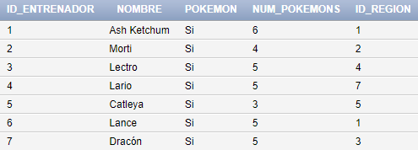

## Tabla Pokemon

INSERT INTO pokemon VALUES(001,'Planta','Osado',1,1);

INSERT INTO pokemon VALUES(004,'Fuego','Huraña',1,1);

INSERT INTO pokemon VALUES(007,'Agua','Osado',1,1);

INSERT INTO pokemon VALUES(387,'Planta','Mansa',4,2);

INSERT INTO pokemon VALUES(390,'Fuego','Firme',4,2);

INSERT INTO pokemon VALUES(393,'Agua','Modesto',4,2);

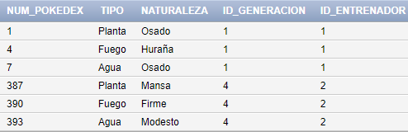

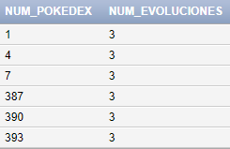

## Tabla Tiene

INSERT INTO tiene VALUES(001,3);

INSERT INTO tiene VALUES(004,3);

INSERT INTO tiene VALUES(007,3);

INSERT INTO tiene VALUES(387,3);

INSERT INTO tiene VALUES(390,3);

INSERT INTO tiene VALUES(393,3);

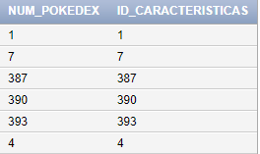

## Tabla cuenta

INSERT INTO cuenta VALUES(001,001);

INSERT INTO cuenta VALUES(004,004);

INSERT INTO cuenta VALUES(007,007);

INSERT INTO cuenta VALUES(387,387);

INSERT INTO cuenta VALUES(390,390);

INSERT INTO cuenta VALUES(393,393);